Aditi Lad - 999081087, Isaac A - 998986575, Conor Hansen - 1000800387
MGEC72H3
Assignment #1

Part i)
Average: 1.0117705% | Geometric Average: 0.6321226% | Standard Deviation: 8.651709%
Minimum Return: -0.23248 | Maximum Return: 0.243745

JPMorgan Chase (JPM):

JP Morgan’s frequency distribution shows a normal distribution, which is slightly negatively skewed. The observation shows that the mean is left of the peak. The average gain for this stock is approximately 1.01% and the geometric mean is 0.63%. The standard deviation is approximately 8.65%, which is relatively higher than the mean. In conclusion JPM is one of the higher risk stocks from this portfolio.
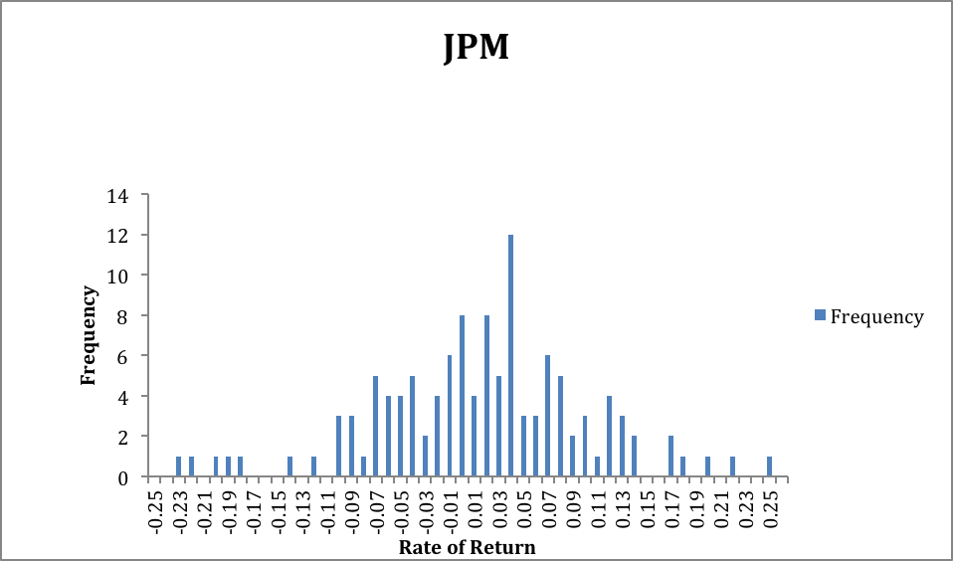

Microsoft Corporation (MSFT):
Average: 1.018645% | Geometric Average: 0.764425% | Standard Deviation: 7.203857%
Minimum Return: -0.16336 | Maximum Return: 0.249491

The frequency graph for Microsoft Corporation also approximates to a negatively skewed normal distribution. The frequency graph also shows that the mean is towards the left side of the peak. The average percentage of return is approximately 1.02% and the geometric mean of the return is 0.76%. A positive value of both means suggests that on average the rate of return is increasing however this is a small increase compared to the standard deviation of 7.2%. Higher the standard error, implying the varied rate of return and which means the risk is higher. It is safe to conclude that Microsoft Corporation stock has undesirable risk level.
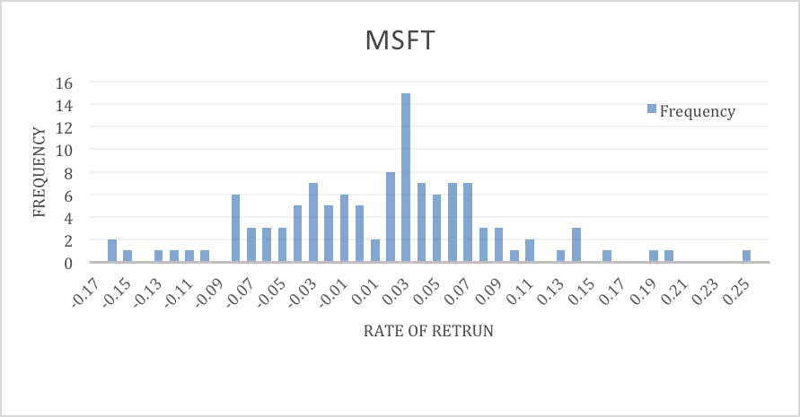

Pfizer (PFZ):

Average: 0.6956509% | Geometric Average: 0.5463294% | Standard Deviation: 5.4691%
Minimum return: -0.17674 | Maximum return: 0.14986

Pfizer’s probability distribution shows a positively skewed normal distribution, implying on average the return will be on the right of the average. The positive skewedness of the frequency distribution shows the rate of the returns is to the right of the peak. The arithmetic and geometric average are approximately 0.69% and 0.54% respectively. The standard deviation is 5.4%. This is show that there is a lower risk and low reward for this stock. The occurrence of the positive skewed frequency and the lower standard error show that this is a less risky stock compared the others in the portfolio.

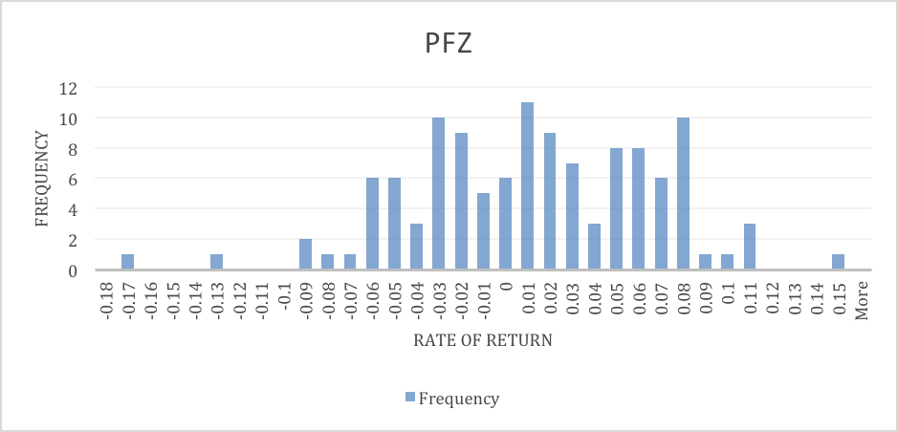

Monsanto (MON):

Average: 1.149486% | Geometric Mean: 3.530885% | Standard Deviation: 8.164058%
Minimum Return: -0.19331 | Maximum Return: 0.258799

Monsanto has a positively skewed normal distribution; the frequency graph below shows that the mean is to the right of the peak. The arithmetic average and the geometric mean is 1.15% and 3.5% respectively. This means that the rate of return is increasing. The Standard deviation is at 8.16% approximately, which much higher than the average mean. We can conclude that the risk out weight the average gains and thus is a risky stock as well.

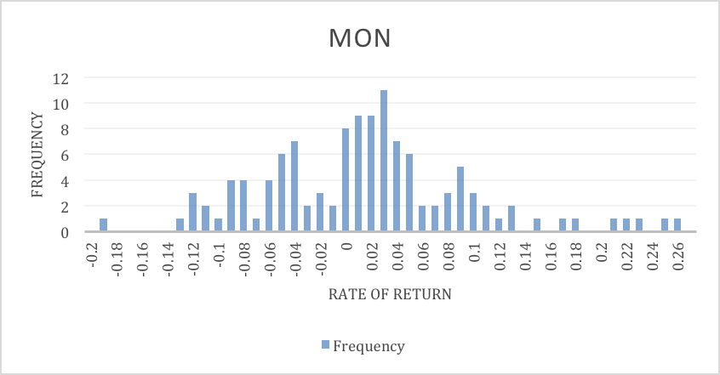

Part ii)

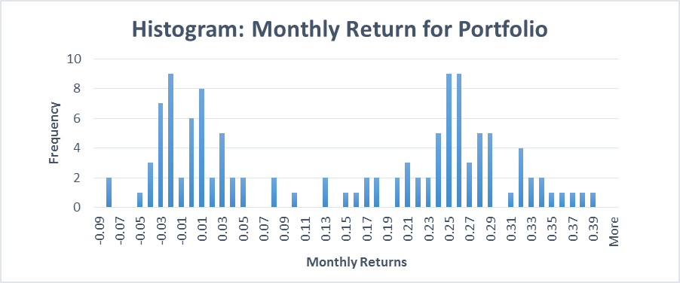

Average: 0.141572 | Geometric mean: 0.133083 | Standard Deviation: 0.13897

- The probability of losing money next month is calculated through the ratio of total number of negative returns (return <0) divided by the total number observed. The number of this portfolio observed a negative return in the past ten years is about 30 times. Therefore, the relative frequency is 30/118, which is 0.254237288.

- Assuming the distribution is normal, the probability of losing money next month can be calculated using the NORMDIST Excel function. Using the arithmetic mean and the standard deviation of the portfolio, 0 as the value, and cumulative distribution, the given value approximates to 15.42%. This value assumes that there is a normal distribution, however the frequency graph is a bimodal distribution. Our sample size is not large enough to be normally distributed and therefore the probability of loss assuming the portfolio distribution is normal is incorrect. The relative frequency is a better approximation comparatively.
- The diversifiable part of the portfolio is 0.00139569 and the non-diversifiable part of the portfolio is 0.017916889. The calculations is on the portfolio tab.
- The diversification achieved by combining these four stocks in the portfolio is the difference between the weighted sums of the standard deviation and the observed standard deviation of the portfolio. This is calculated in the excel file and it shows that in this portfolio we have achieved 6.5% diversification.

